**UNIVERSITY OF WESTMINSTER**

**in collaboration with**

**INFORMATICS INSTITUE OF TECHNOLOGY**

**Advanced Client-Side Development**

**5COSC026C.1**

Name – Herath Mudiyanselage Parama Bhadantha Bandara Herath

UOW Number – w2051807

IIT Number – 20230993

Module Leader – Mrs. Theja Perera

Assignment Type – Individual Coursework

Course work name – Portfolio Design (Report with Code, Screenshots and Diary of the Portfolio for the ICT)

**HOMEPAGE**

<!DOCTYPE html>

<html lang="en">

<head>

    <meta charset="UTF-8">

    <meta name="viewport" content="width=device-width, initial-scale=1.0">

    <title>Home | Parama Herath</title>

    <link rel="preconnect" href="https://fonts.googleapis.com">

    <link rel="preconnect" href="https://fonts.gstatic.com" crossorigin>

    <link href="https://fonts.googleapis.com/css2?family=Inter:ital,opsz,wght@0,14..32,100..900;1,14..32,100..900&display=swap" rel="stylesheet">

    <link rel="stylesheet" href="style.css">

</head>

<body>

    <!-- Header with the Navigation Bar -->

    <header>

        <a href="index.html" id="logo">Parama Herath</a>

        <nav>

            <a href="about.html">About</a><a href="projects.html">Projects</a><a href="contact.html">Contact</a>

        </nav>

    </header>

    <section class="container intro" id="intro-container">

        <h1 class="level1heading">Hey there, I'm Parama!</h1>

        <p class="level1text">I'm a passionate Computer Science undergrad, from Colombo, Sri Lanka, specializing in web & mobile/desktop development. I focus on building creative, impactful digital solutions. Take a look around to see what I've been upto, explore my projects, or get in touch!</p>

        <a href="https://drive.google.com/file/d/16GjMomYScmgPDVEuuUUzGeB_gI-PByu6/view?usp=sharinghttps://drive.google.com/file/d/16GjMomYScmgPDVEuuUUzGeB_gI-PByu6/view?usp=sharing" class="btn-link">Checkout my Resume!</a>

    </section>

    <!-- Featured Projects Showcase -->

    <section class="container" id="projects-container">

        <h1 class="level2heading">Featured Projects</h1>

        <p class="level2text">Here are some of my highlights, including projects I've undertaken as a first-year Computer Science undergrad. These projects showcase my creativity and problem-solving skills as I explored various aspects of technology and programming.</p>

        <div class="project-showcase project-showcase-home">

            <div class="project">

                <div class="project-thumbnail">

                    <img src="images/project1.png" alt="project-1-thumbnail">

                </div>

                <div class="project-body">

                    <h2 class="level3heading">Tech & Tales Blogs</h2>

                    <p class="level3text project-body-text">"Tech & Tales" is a blog crafted by me, where I explore and share my reflections and reception on current and upcoming tech trends, news, rumors, insights, leaks, and emerging innovations. Check it out and make sure to provide your opinions!</p>

                    <a href="blogs.html" class="btn-link explore-button"></a>

                </div>

            </div>

            <div class="project project-reverse">

                <div class="project-body">

                    <h2 class="level3heading">Real-Time Ticketing System</h2>

                    <p class="level3text project-body-text">A full-stack app built with React and Spring Boot to manage event ticket releases and purchases concurrently. Using the Producer-Consumer pattern, it ensures data integrity in a multi-threaded environment, offering real-time availability and seamless booking.</p>

                    <a href="https://github.com/ParamaHerath/Real-Time-Event-Ticketing-System-for-OOP-Module" class="btn-link explore-button"></a>

                </div>

                <div class="project-thumbnail">

                    <img src="images/project2.png" alt="project-2-thumbnail">

                </div>

            </div>

            <div class="project">

                <div class="project-thumbnail">

                    <img src="images/project4.png" alt="project-4-thumbnail">

                </div>

                <div class="project-body">

                    <h2 class="level3heading">Plane Management System</h2>

                    <p class="level3text project-body-text">A CLI based application written in Java to book, manage, visualize seating plans, print tickets, etc. It makes use of OOP concepts of Objects and Classes to achieve the functionality.</p>

                    <a href="https://github.com/ParamaHerath/Plane-Management-System-for-SD2-Module" class="btn-link explore-button"></a>

                </div>

            </div>

        </div>

    </section>

    <!-- Social Media Linking -->

    <section class="container" id="socials-container">

        <h1 class="level2heading">Find me in Socials</h1>

        <p class="level2text">Connect with me on social media for my latest updates and insights into my work. </p>

        <div id="social-links">

            <a href="https://lk.linkedin.com/in/parama-herath"><i class="fa-brands fa-linkedin-in"></i></a>

            <a href="https://github.com/ParamaHerath"><i class="fa-brands fa-github"></i></a>

            <a href="https://www.instagram.com/parama__01/"><i class="fa-brands fa-instagram"></i></a>

            <a href="https://wa.me/+94774852697"><i class="fa-brands fa-whatsapp"></i></a>

            <a href="https://www.youtube.com/@parama_01"><i class="fa-brands fa-youtube"></i></a>

        </div>

    </section>

    <!-- Newsletter Subscription Section -->

    <section class="container" id="newsletter-container">

        <h1 class="level2heading">Join my Newsletter!</h1>

        <p class="level2text">Stay up-to-date with my latest projects, blogs, industry insights and trends! Join my newsletter to get exclusive content delivered straight to your inbox.</p>

        <form action="https://formspree.io/f/mgveebyo" method="POST" id="newsletter-form">

            <input type="text" id="name" placeholder="First Name" required><br>

            <input type="email" id="email" placeholder="Email - example@domain.com" required><br>

            <button type="submit">Subscribe!</button>

        </form>

    </section>

    <!-- Common Sitewide Footer -->

    <footer>

        <div class="container" id="footer-container">

            <div>

                <h3>Navigation</h3>

                <p>

                    <a href="index.html">Home</a>

                    <a href="about.html">About</a><br>

                    <a href="projects.html">Projects</a>

                    <a href="contact.html">Contact</a><br>

                    <a href="blogs.html">Blogs</a>

                    <a href="#top">Top ▲</a>

                </p>

            </div>

            <div>

                <h3>Contact</h3>

                <ul>

                    <li><a href="mailto:paramaherath@gmail.com">paramaherath@gmail.com</a></li>

                    <li>+94774852697</li>

                    <li>126, Galle Road, Colombo 02<li>

                </ul>

            </div>

            <div>

                <h3>Privacy Policy</h3>

                <p>Any personal information shared through this site will be kept confidential, and are not shared with any third party.</p>

            </div>

        </div>

        <div class="container" id="legal-notice-container">

            <p>© 2024 Parama Herath - All Rights Reserved</p>

        </div>

    </footer>

    <script src="https://kit.fontawesome.com/fe77f908f5.js" crossorigin="anonymous"></script>

    <script src="script.js"></script>

</body>

</html>

**ABOUT PAGE**

<!DOCTYPE html>

<html lang="en">

<head>

<meta charset="UTF-8">

<meta name="viewport" content="width=device-width, initial-scale=1.0">

<title>About | Parama Herath</title>

<link rel="preconnect" href="https://fonts.googleapis.com">

<link rel="preconnect" href="https://fonts.gstatic.com" crossorigin>

<link href="https://fonts.googleapis.com/css2?family=Inter:ital,opsz,wght@0,14..32,100..900;1,14..32,100..900&display=swap" rel="stylesheet">

<link rel="stylesheet" href="style.css">

</head>

<body>

<!-- Header with the Navigation Bar -->

<header>

<a href="index.html" id="logo">Parama Herath</a>

<nav>

<a href="about.html">About</a><a href="projects.html">Projects</a><a href="contact.html">Contact</a>

</nav>

</header>

<!-- Intro section with the animation -->

<section class="container intro">

<h1 class="level1heading">Hey there, I'm Parama!</h1>

<h3 class="level4heading" id="animated-heading">

<div><div>Freelance Web Developer</div></div>

<div><div>UI & UX Designer</div></div>

<div><div>Undergraduate</div></div>

<div><div>Binge Watcher</div></div>

<div><div>Freelance Web Developer</div></div>

</h3>

</section>

<section class="container" id="about-container">

<h2 class="level2heading">About Me</h2>

<div>

<div id="photo-container">

<img src="images/dp.jpg" id="photo" alt="photo-of-myself">

</div>

<p class="level2text">Hello there! I’m a 2nd-year Computer Science undergraduate at the Informatics Institute of Technology (IIT) in Sri Lanka, affiliated with the University of Westminster, UK. I’m on track to complete my Bachelor’s degree by September 2027, specializing in web and mobile/desktop application design and development. Alongside my studies, I actively work on freelance projects, allowing me to apply my skills to real-world scenarios and collaborate with clients to bring their ideas to life.</p>

<p class="level2text">My journey into tech began with a passion for problem-solving and an urge to improve the designs I saw around me—whether it was websites, apps, or everyday digital interfaces. Over time, this passion evolved into a clear mission: to build reliable, user-friendly software with sleek and modern UI/UX components that resonate with users. I thrive on crafting solutions that not only function well but also deliver seamless, engaging experiences that make technology feel intuitive and accessible.</p>

<p class="level2text">Beyond academics, I enjoy urban photography and exploring cityscapes, finding inspiration in the blend of architecture, people, and vibrant urban life. I love listening to Pop, Hip-Hop, and EDM, which keeps me motivated and upbeat. Watching movies, documentaries, and TV serials, as well as reading books, articles, magazines and blogs, fuel my curiosity and keeps me open to new perspectives. I also enjoy browsing YouTube for tutorials and insights on tech and design, along with light-hearted content like memes, which add a bit of humor and creativity to my day. These varied interests often spark ideas for creative design and user-centered features in my projects, giving me fresh insights into how digital and real-world environments blend to shape meaningful interactions.</p>

<p class="level2text">Looking ahead, I aspire to create applications that truly enhance everyday life, merging intuitive functionality with a positive social impact. My goal is to build a career where I contribute to developing digital experiences that people trust, enjoy, and rely on, with a strong emphasis on quality, usability, and a modern aesthetic that brings value to users from all walks of life.</p>

</div>

</section>

<section class="container" id="details-container">

<h2 class="level2heading">My Technical Expertise</h2>

<div id="expertise-container">

<div class="expertise-section">

<h3 class="level4heading expertise-topic">Languages</h3>

<p class="level3text expertise-content">Python, Java, HTML, CSS, JavaScript, TypeScript, SQL</p>

</div>

<div class="expertise-section">

<h3 class="level4heading expertise-topic">Libraries & Frameworks</h3>

<p class="level3text expertise-content">Bootstrap | React | Angular | Node.js</p>

</div>

<div class="expertise-section">

<h3 class="level4heading expertise-topic">Development Tools</h3>

<p class="level3text expertise-content">Git | GitHub | Visual Studio Code | pip | npm</p>

</div>

</div>

</section>

<!-- Common Sitewide Footer -->

<footer>

<div class="container" id="footer-container">

<div>

<h3>Navigation</h3>

<p>

<a href="index.html">Home</a>

<a href="about.html">About</a><br>

<a href="projects.html">Projects</a>

<a href="contact.html">Contact</a><br>

<a href="blogs.html">Blogs</a>

<a href="#top">Top ▲</a>

</p>

</div>

<div>

<h3>Contact</h3>

<ul>

<li><a href="mailto:paramaherath@gmail.com">paramaherath@gmail.com</a></li>

<li>+94774852697</li>

<li>126, Galle Road, Colombo 02<li>

</ul>

</div>

<div>

<h3>Privacy Policy</h3>

<p>Any personal information shared through this site will be kept confidential, and are not shared with any third party.</p>

</div>

</div>

<div class="container" id="legal-notice-container">

<p>© 2024 Parama Herath - All Rights Reserved</p>

</div>

</footer>

<script src="script.js"></script>

</body>

</html>

**PROJECTS PAGE**

<!DOCTYPE html>

<html lang="en">

<head>

    <meta charset="UTF-8">

    <meta name="viewport" content="width=device-width, initial-scale=1.0">

    <title>Projects | Parama Herath</title>

    <link rel="preconnect" href="https://fonts.googleapis.com">

    <link rel="preconnect" href="https://fonts.gstatic.com" crossorigin>

    <link href="https://fonts.googleapis.com/css2?family=Inter:ital,opsz,wght@0,14..32,100..900;1,14..32,100..900&display=swap" rel="stylesheet">

    <link rel="stylesheet" href="style.css">

</head>

<body>

    <!-- Header with the Navigation Bar -->

    <header>

        <a href="index.html" id="logo">Parama Herath</a>

        <nav>

            <a href="about.html">About</a><a href="projects.html">Projects</a><a href="contact.html">Contact</a>

        </nav>

    </header>

    <section class="container intro">

        <h1 class="level1heading" id="title">My Projects</h1>

        <p class="level1text">Welcome to my projects page! Here, you’ll find a collection of work reflecting my journey as a Computer Science student. Most projects here were created in my first year or from personal interests. Each has helped build my foundation and deepen my skills. I’m excited to keep this collection growing.</p>

    </section>

    <!-- (All) Projects Showcase -->

    <section class="container" id="featured-projects-container" style="margin-top: -6rem;"> <!-- Negative margin to remove the margins of div with project-showcase class inside the section -->

        <div class="project-showcase">

            <div class="project">

                <div class="project-thumbnail">

                    <img src="images/project1.png" alt="project-1-thumbnail">

                </div>

                <div class="project-body">

                    <h2 class="level3heading">Tech & Tales Blogs</h2>

                    <p class="level3text project-body-text">"Tech & Tales" is a blog crafted by me, where I explore and share my reflections and reception on current and upcoming tech trends, news, rumors, insights, leaks, and emerging innovations. Check it out and make sure to provide your opinions!</p>

                    <a href="blogs.html" class="btn-link explore-button"></a>

                </div>

            </div>

            <div class="project project-reverse">

                <div class="project-body">

                    <h2 class="level3heading">Real-Time Ticketing System</h2>

                    <p class="level3text project-body-text">A full-stack app built with React and Spring Boot to manage event ticket releases and purchases concurrently. Using the Producer-Consumer pattern, it ensures data integrity in a multi-threaded environment, offering real-time availability and seamless booking.</p>

                    <a href="https://github.com/ParamaHerath/Real-Time-Event-Ticketing-System-for-OOP-Module" class="btn-link explore-button"></a>

                </div>

                <div class="project-thumbnail">

                    <img src="images/project2.png" alt="project-2-thumbnail">

                </div>

            </div>

            <div class="project">

                <div class="project-thumbnail">

                    <img src="images/project3.png" alt="project-3-thumbnail">

                </div>

                <div class="project-body">

                    <h2 class="level3heading">The Wildhaven Initiative Website</h2>

                    <p class="level3text project-body-text">A multi page website, built with HTML, CSS and JavaScript, by a team of 4, for an imaginary organization that is dedicated to United Nation's SDG 15 - Life on Land, featuring a user profile builder, feedback form, gallery, shop, etc.</p>

                    <a href="https://github.com/ParamaHerath/The-Wildhaven-Initiative-Website-for-WDD-Module" class="btn-link explore-button"></a>

                </div>

            </div>

            <div class="project project-reverse">

                <div class="project-body">

                    <h2 class="level3heading">Plane Management System</h2>

                    <p class="level3text project-body-text">A CLI based application written in Java to book, manage, visualize seating plans, print tickets, etc. It makes use of OOP concepts of Objects and Classes to achieve the functionality.</p>

                    <a href="https://github.com/ParamaHerath/Plane-Management-System-for-SD2-Module" class="btn-link explore-button"></a>

                </div>

                <div class="project-thumbnail">

                    <img src="images/project4.png" alt="project-4-thumbnail">

                </div>

            </div>

            <div class="project">

                <div class="project-thumbnail">

                    <img src="images/project5.png" alt="project-5-thumbnail">

                </div>

                <div class="project-body">

                    <h2 class="level3heading">Student Progression Tracker</h2>

                    <p class="level3text project-body-text">A CLI and semi-GUI based application written in Python to let Students or a Staff member to enter a student's credits at pass, defer and fail and track their outcome. A bar graph graphic is shown after multiple student details are entered.</p>

                    <a href="https://github.com/ParamaHerath/Student-Progression-Tracker-for-SD1-Module" class="btn-link explore-button"></a>

                </div>

            </div>

            <div class="project project-reverse">

                <div class="project-body">

                    <h2 class="level3heading">View more of my Projects at GitHub</h2>

                    <p class="level3text project-body-text">Lorem, ipsum dolor sit amet consectetur adipisicing elit. Distinctio eos deleniti ad fugit accusantium saepe dolores ex, quidem sapiente, dolor dignissimos est alias dolore assumenda, nemo dicta quas ab nulla.</p>

                    <a href="https://github.com/ParamaHerath?tab=repositories" class="btn-link">Browse</a>

                </div>

                <div class="project-thumbnail">

                    <img src="images/project6.jpg" alt="project-6-thumbnail">

                </div>

            </div>

        </div>

    </section>

    <!-- Common Sitewide Footer -->

    <footer>

        <div class="container" id="footer-container">

            <div>

                <h3>Navigation</h3>

                <p>

                    <a href="index.html">Home</a>

                    <a href="about.html">About</a><br>

                    <a href="projects.html">Projects</a>

                    <a href="contact.html">Contact</a><br>

                    <a href="blogs.html">Blogs</a>

                    <a href="#top">Top ▲</a>

                </p>

            </div>

            <div>

                <h3>Contact</h3>

                <ul>

                    <li><a href="mailto:paramaherath@gmail.com">paramaherath@gmail.com</a></li>

                    <li>+94774852697</li>

                    <li>126, Galle Road, Colombo 02<li>

                </ul>

            </div>

            <div>

                <h3>Privacy Policy</h3>

                <p>Any personal information shared through this website will be kept confidential, and are not shared with any third party.</p>

            </div>

        </div>

        <div class="container" id="legal-notice-container">

            <p>© 2024 Parama Herath - All Rights Reserved</p>

        </div>

    </footer>

    <script src="script.js"></script>

</body>

</html>

**CONTACT PAGE**

<!DOCTYPE html>

<html lang="en">

<head>

    <meta charset="UTF-8">

    <meta name="viewport" content="width=device-width, initial-scale=1.0">

    <title>Contact | Parama Herath</title>

    <link rel="preconnect" href="https://fonts.googleapis.com">

    <link rel="preconnect" href="https://fonts.gstatic.com" crossorigin>

    <link href="https://fonts.googleapis.com/css2?family=Inter:ital,opsz,wght@0,14..32,100..900;1,14..32,100..900&display=swap" rel="stylesheet">

    <link rel="stylesheet" href="style.css">

</head>

<body>

    <!-- Header with the Navigation Bar -->

    <header>

        <a href="index.html" id="logo">Parama Herath</a>

        <nav>

            <a href="about.html">About</a><a href="projects.html">Projects</a><a href="contact.html">Contact</a>

        </nav>

    </header>

    <!-- Section to let viewers contact me directly -->

    <section class="container intro">

        <h1 class="level1heading" id="title">Contact Me Directly!</h1>

        <p class="level1text">Thank you for visiting my portfolio! I’m always open to discussing new ideas, answering questions, or exploring ways we can work together. If you'd like to reach out directly, feel free to hit the button below to send me a mail!</p>

        <a href="mailto:paramaherath@gmail.com" class="btn-link">paramaherath@gmail.com</a>

    </section>

    <!-- Section with the form to let viewers send me a message -->

    <section class="container" id="message-container">

        <h2 class="level2heading">Drop a message instead ?</h2>

        <p class="level2text">If email isn’t your preference, feel free to use the form below. Whether you have questions, feedback, or want to chat about a potential collaboration, I’d love to connect. Just fill out the form, and I’ll get back to you soon.</p>

        <form action="" method="POST" id="message-form">

            <div class="form-label"><label for="name">Your Name*</label></div>

            <input type="text" id="name" name="name" placeholder="ex: John Doe" required><br>

            <div class="form-label"><label for="email">Your Email*</label></div>

            <input type="email" id="email" name="email" placeholder="ex: example@domain.com" required><br>

            <div class="form-label"><label for="subject">Subject*</label></div>

            <input type="text" id="subject" name="subject" placeholder="Subject" required><br>

            <div class="form-label"><label for="message">Message</label></div>

            <textarea name="message" placeholder="Your message"></textarea><br>

            <button type="submit">Send Message</button>

        </form>

    </section>

    <!-- Common Sitewide Footer -->

    <footer>

        <div class="container" id="footer-container">

            <div>

                <h3>Navigation</h3>

                <p>

                    <a href="index.html">Home</a>

                    <a href="about.html">About</a><br>

                    <a href="projects.html">Projects</a>

                    <a href="contact.html">Contact</a><br>

                    <a href="blogs.html">Blogs</a>

                    <a href="#top">Top ▲</a>

                </p>

            </div>

            <div>

                <h3>Contact</h3>

                <ul>

                    <li><a href="mailto:paramaherath@gmail.com">paramaherath@gmail.com</a></li>

                    <li>+94774852697</li>

                    <li>126, Galle Road, Colombo 02<li>

                </ul>

            </div>

            <div>

                <h3>Privacy Policy</h3>

                <p>Any personal information shared through this website will be kept confidential, and are not shared with any third party.</p>

            </div>

        </div>

        <div class="container" id="legal-notice-container">

            <p>© 2024 Parama Herath - All Rights Reserved</p>

        </div>

    </footer>

    <script src="script.js"></script>

</body>

</html>

**BLOGS PAGE**

<!DOCTYPE html>

<html lang="en">

<head>

    <meta charset="UTF-8">

    <meta name="viewport" content="width=device-width, initial-scale=1.0">

    <title>Blogs | Parama Herath</title>

    <link rel="preconnect" href="https://fonts.googleapis.com">

    <link rel="preconnect" href="https://fonts.gstatic.com" crossorigin>

    <link href="https://fonts.googleapis.com/css2?family=Inter:ital,opsz,wght@0,14..32,100..900;1,14..32,100..900&display=swap" rel="stylesheet">

    <link href="https://fonts.googleapis.com/css2?family=Poppins:ital,wght@0,100;0,200;0,300;0,400;0,500;0,600;0,700;0,800;0,900;1,100;1,200;1,300;1,400;1,500;1,600;1,700;1,800;1,900&display=swap" rel="stylesheet">

    <link rel="stylesheet" href="style.css">

</head>

<body>

    <!-- Header with the Navigation Bar -->

    <header>

        <a href="index.html" id="logo">Parama Herath</a>

        <nav>

            <a href="about.html">About</a><a href="projects.html">Projects</a><a href="contact.html">Contact</a>

        </nav>

    </header>

    <section class="container intro" id="logo-container">

        <h1 class="level1heading" id="blog-logo-text">

            Tech & Tales Blogs™

        </h1>

    </section>

    <!-- Section for blog posts that are independent, and within the page -->

    <section class="container" id="first-section">

        <h2 class="level2heading">Featured Blog Posts</h2>

        <p class="level2text">Welcome to my curated selection of featured blog posts! Here, you'll find a handpicked collection of my favourite articles.</p>

            <article class="content-container">

                <h3>React vs. Angular vs. Vue in 2024: Which One Should You Learn?</h3>

                <p>Posted : <time datetime="2024-11-02T14:30">November 2, 2024, 14:30</time></p>

                <p>With an evolving web development landscape, choosing the right frontend framework is essential. In 2024, React, Angular, and Vue continue to dominate as popular frameworks, each offering distinct benefits.</p>

                <p>React is highly favored for its flexibility and extensive community support. Developed by Facebook, it provides a component-based architecture that allows for reusable UI components. React’s virtual DOM boosts performance, making it ideal for dynamic, large-scale applications. If you prefer versatility and a vast ecosystem, React is a strong choice.</p>

                <p>Angular, developed by Google, is a comprehensive framework that provides an out-of-the-box solution for building complex applications. With TypeScript as its primary language, Angular is more structured, offering built-in solutions for routing, state management, and form validation. This makes it suitable for enterprise-grade applications requiring robust structure.</p>

                <p>Vue is known for its gentle learning curve, lightweight nature, and dual-mode capability as both a library and a framework. It’s highly adaptable, making it excellent for projects ranging from single-page applications to smaller components within larger apps.</p>

                <p>Ultimately, the choice depends on your needs: React for flexibility, Angular for enterprise power, and Vue for simplicity and speed. Each has its strengths—choose the one that aligns best with your project and goals.</p>

            </article>

            <article class="content-container">

                <h3>The Future of AI-Driven Personal Assistants: Beyond Siri and Alexa</h3>

                <p>Posted : <time datetime="2024-10-27T19:45">October 27, 2024, 19:45</time></p>

                <p>AI-driven personal assistants are evolving quickly, pushing past early limitations seen with Siri and Alexa. In 2024, advanced AI tools like ChatGPT's latest voice capabilities are redefining what virtual assistants can offer. With ChatGPT’s voice feature, users can engage in fluid, natural conversations, mimicking human-like dialogue far beyond traditional, command-driven systems.</p>

                <p>Unlike Siri or Alexa, which primarily follow scripted responses, ChatGPT’s voice assistant adapts dynamically, making responses more context-aware. For example, it can help users troubleshoot issues, walk through multi-step processes, or provide detailed explanations on complex topics, all in real-time, flowing conversation. This shift towards more conversational AI enables a deeper, more engaging experience, ideal for use cases ranging from professional support to personal productivity.</p>

                <p>As AI assistants become better at understanding context, tone, and even subtle nuances in voice, we’re entering an era where these tools will act more like true digital companions, offering empathy, insight, and sophisticated support. While Siri and Alexa paved the way, advanced conversational AI is expanding the boundaries of what personal assistants can accomplish, transforming everyday interactions.</p>

            </article>

    </section>

    <!-- Section for blog posts that are dependent, and hosted elsewhere -->

    <section class="container" id="second-section">

        <h2 class="level2heading">More Blog Posts</h2>

        <p class="level2text">Here, you'll find a more of my posts across various domains related to tech and tech gadgets. Feel free to explore and check them out if you spot something you fancy!</p>

        <div  id="more-posts-container">

            <aside class="content-container">

                <h3>The Oversimplification Trend in Logo Design: Is Less Really More?</h3>

                <p>Posted : <time datetime="2024-10-20T10:25">October 20, 2024, 10:25</time></p>

                <p>In recent years, brands have leaned into minimalism, simplifying logos down to the bare essentials. This article examines whether the trend toward overly simplified logos is making brands more accessible or stripping them of their unique identity and recognizability.</p>

                <a href="https://docs.google.com/document/d/1yVHdzRMH2D4fV69-i5HDZqcwK5kw0hDfyXwAurkCpA0/edit?usp=sharing" class="btn-link">Read More...</a>

            </aside>

            <aside class="content-container">

                <h3>Google vs. Ad Blockers: How Manifest V3 Could Change the Web Browsing Experience</h3>

                <p>Posted : <time datetime="2024-10-11T22:15">October 11, 2024, 22:15</time></p>

                <p>Google’s shift to Manifest V3 in Chrome is set to impact ad blockers like uBlock Origin, sparking debate over online privacy and user control. This article breaks down what Manifest V3 means for users and how it may reshape the browsing experience.</p>

                <a href="https://docs.google.com/document/d/1y9YU2eAub_5lqldbXV5vZcYObUu3XYnHDpBiqfbY_t0/edit?usp=sharing" class="btn-link">Read More...</a>

            </aside>

            <aside class="content-container">

                <h3>Why It’s Time for Windows to Fully Embrace Fluent Design and Retire Legacy UI</h3>

                <p>Posted : <time datetime="2024-10-02T02:55">October 02, 2024, 02:55</time></p>

                <p>With Fluent Design, Microsoft has introduced a sleek, modern look across parts of Windows, but many legacy UI elements still linger. This article explores the need for Windows to fully transition to Fluent Design, highlighting both its cosmetic, and practical benefits.</p>

                <a href="https://docs.google.com/document/d/1OEB3hJXXojU0nXdCgn24LGHhW5-bo-LCjK0elQUOjRs/edit?usp=sharing" class="btn-link">Read More...</a>

            </aside>

        </div>

    </section>

    <!-- Common Sitewide Footer -->

    <footer>

        <div class="container" id="footer-container">

            <div>

                <h3>Navigation</h3>

                <p>

                    <a href="index.html">Home</a>

                    <a href="about.html">About</a><br>

                    <a href="projects.html">Projects</a>

                    <a href="contact.html">Contact</a><br>

                    <a href="blogs.html">Blogs</a>

                    <a href="#top">Top ▲</a>

                </p>

            </div>

            <div>

                <h3>Contact</h3>

                <ul>

                    <li><a href="mailto:paramaherath@gmail.com">paramaherath@gmail.com</a></li>

                    <li>+94774852697</li>

                    <li>126, Galle Road, Colombo 02<li>

                </ul>

            </div>

            <div>

                <h3>Privacy Policy</h3>

                <p>Any personal information shared through this website will be kept confidential, and are not shared with any third party.</p>

            </div>

        </div>

        <div class="container" id="legal-notice-container">

            <p>© 2024 Parama Herath - All Rights Reserved</p>

        </div>

    </footer>

    <script src="script.js"></script>

</body>

</html>

**STYLESHEET**

/* Reseting Default Styles */

/* Applying of an imported font via Google Fonts sitewide */

* {

    margin: 0;

    padding: 0;

    box-sizing: border-box;

    text-decoration: none;

    list-style: none;

    font-family: Inter, sans-serif;

    color: rgb(253, 253, 253);

}

body {

    background-image: url(images/bg-landscape.jpg);

    background-size: cover;

    background-attachment: fixed;

}

/* Styles for the Header and Navigation Bar */

header {

    position: fixed;

    top: 0;

    left: 0;

    width: 100%;

    background: rgba(0, 0, 0, 0.6);

    backdrop-filter: blur(0.5rem);

    display: flex;

    justify-content: space-between;

    align-items: center;

    z-index: 100;

}

#logo {

    font-size: 1.8rem;

    font-weight: 800;

    padding: 1.4rem;

}

nav a {

    font-size: 1.2rem;

    font-weight: 700;

    border-left: 1px solid rgba(255, 255, 255, 0.171);

    padding: 1.75rem;

}

.container {

    width: 100%;

    max-width: 1400px;

    margin: 0 auto; /* Center align */

    padding: 3rem;

    margin-bottom: 3rem;

}

.level1heading{

    font-size: 3.5rem;

    padding: 1.5rem;

}

.level1text{

    font-size: 1.5rem;

    padding: 1.5rem;

    margin-bottom: 1.5rem;

}

.level2heading{

    font-size: 3rem;

    margin-bottom: 1.5rem;

    text-shadow: 0.2rem 0.2rem 0.1rem rgba(0, 0, 0, 0.4);

}

.level2text{

    font-size: 1.25rem;

}

.level3heading{

    font-size: 2rem;

}

.level3text{

    font-size: 1.15rem;

}

.level4heading{

    font-size: 1.75rem;

}

.level4text{

    font-size: 1.05rem;

}

/* Anchor tags that would link to a source */

.btn-link {

    color: black;

    display: inline-block;

    font-weight: 700;

    border: 0;

    border-radius: 0.5rem;

    background-color: white;

    text-align: center;

    transition: transform 0.25s ease;

}

.btn-link:hover {

    transform: scale(1.075);

}

/* First section */

.intro {

    margin-top: 7rem;

    text-align: center;

}

.intro a {

    font-size: 1.5rem;

    padding: 1.5rem;

}

.project-showcase {

    margin-top: 3rem;

    display: flex;

    flex-direction: column;

    border-radius: 0.5rem;

    overflow: hidden;

}

.project {

    display: flex;

    width: 100%;

    background-color: rgba(0, 0, 0, 0.4);

    border-bottom: 0.1rem solid rgba(255, 255, 255, 0.2);

    flex-direction: row;

}

.project a {

    font-size: 1.25rem;

    padding: 0.5rem 2rem 0.5rem 2rem;

    margin-top: 20%;

}

.project-thumbnail {

    width: 70%;

    padding: 1rem 1rem 1rem 1rem;

    border-radius: 0.5rem;

}

.project img {

    object-fit: cover;

    width: 100%;

}

.project-body {

    display: flex;

    width: 30%;

    flex-direction: column;

    padding: 3rem;

}

.project-body h2 {

    margin-bottom: 20%;

}

/* Selecting nth project for omitting borders where necessary */

.project-showcase :nth-of-type(6) {

    border-bottom: 0;

}

.project-showcase-home :nth-of-type(3) {

    border-bottom: 0;

}

/* Using after pseudo element to add generated content */

.explore-button::after{

    content: "Explore";

}

/* Social Media icons that wrap and fit based on available space */

#social-links {

    display: flex;

    flex-wrap: wrap;

    gap: 1rem;

    margin-top: 1.5rem;

    font-size: 3rem;

    padding: 1rem 0 1rem 0;

}

/* Selecting all icons descending from anchor tags inside the social links element */

#social-links a i{

    background-color: rgba(0, 0, 0, 0.4);

    border: 0.01rem solid rgba(255, 255, 255, 0.4);

    padding: 2rem;

    border-radius: 0.5rem;

    transition: transform 0.25s ease;

}

#social-links a i:hover{

    transform: scale(1.075);

}

/* Independently adding on hover backgrund colors for each anchor tag hosting an icon */

#social-links a:nth-child(1):hover i {

    background-color: #0077b5; /* LinkedIn */

}

#social-links a:nth-child(2):hover i {

    background-color: black; /* GitHub */

}

#social-links a:nth-child(3):hover i {

    background: linear-gradient(45deg, #833ab4, #fd1d1d, #fcb045); /* Instgram */

}

#social-links a:nth-child(4):hover i {

    background-color: #25D366; /* WhatsApp */

}

#social-links a:nth-child(5):hover i {

    background-color: #FF0000; /* YouTube */

}

form {

    width: 50%;

    margin: 0 auto;

    margin-top: 3rem;

}

.form-label {

    font-size: 1.4rem;

    font-weight: 700;

    margin-bottom: 0.85rem;

}

form input, textarea {

    padding: 0.5rem;

    color: black;

    font-size: 1.2rem;

    margin-bottom: 2rem;

    width: 100%;

    border-radius: 0.5rem;

}

/* Using validity pseudo class to cue the user on form filling */

form input:valid {

    border: 0.25rem solid rgb(0, 255, 149);

}

form input:invalid {

    border: 0.25rem solid red;

}

/* Ensuring the above styles aren't applied when the page is initially loaded */

form input:invalid:placeholder-shown {

    border: none;

}

form textarea {

    resize: vertical;

    height: 10rem;

}

/* Selecting all buttons with attribute of type submit */

button[type="submit"] {

    padding: 0.5rem;

    background-color: rgb(0, 255, 149);

    color: black;

    border-radius: 0.5rem;

    font-weight: 700;

    font-size: 1.4rem;

    margin-bottom: 1rem;

    width: 100%;

    border: 0;

}

button[type="submit"]:hover{

    background-color: rgb(46, 223, 149);

    cursor: pointer;

}

#animated-heading {

    overflow: hidden;

    height: 2.5rem;

}

#animated-heading div div {

    display: inline-block;

    margin-bottom: 2rem;

}

#animated-heading div:nth-child(1){

    animation: slide-up 8s linear infinite;

}

/* Slide-up animation for displaying my roles/hobbies */

@keyframes slide-up {

    0% {margin-top: 0rem;}         /* Show "Web Developer" */

    20% {margin-top: 0rem;}        /* Hold */

    25% {margin-top: -4rem;}       /* Show "UI/UX Enthusiast" */

    45% {margin-top: -4rem;}       /* Hold */

    50% {margin-top: -8rem;}       /* Show "Undergraduate" */

    70% {margin-top: -8rem;}       /* Hold */

    75% {margin-top: -12rem;}      /* Show "Binge Watcher" */

    95% {margin-top: -12rem;}      /* Hold */

    100% {margin-top: -16rem;}     /* Loop back to "Web Developer" */

}

#photo-container {

    margin-right: 3rem;

    margin-bottom: 0.75rem;

    float: left;

}

#photo {

    width: 24rem;

}

#about-container p{

    margin-bottom: 1.5rem;

    text-align: justify;

}

#expertise-container {

    display: flex;

    background-color: rgba(0, 0, 0, 0.4);

    border-radius: 0.5rem;

    text-align: center;

}

.expertise-section {

    display: flex;

    flex: 1 1 33%;

    flex-direction: column;

    padding-right: 3rem;

    padding: 3rem;

    border-right: 0.1rem solid rgba(255, 255, 255, 0.4);

}

.expertise-section:nth-of-type(3) {

    border-right: 0;

}

.expertise-topic{

    margin-bottom: 2rem;

}

#message-container {

    margin-top: 3.5rem;

    margin-bottom: 3.5rem;

}

/* Logo for the Blogs page */

/* Applying of the 2nd imported font via Google Fonts */

#blog-logo-text {

    font-family: "Poppins", sans-serif;

    font-size: 5rem;

    color: rgb(0, 255, 149);

    text-shadow: 1rem 0.5rem 1.5rem rgb(0, 119, 255);

}

/* Common class for articles and aside tags */

.content-container {

    background-color: rgba(0, 0, 0, 0.4);

    border-radius: 0.5rem;

    padding: 3rem;

    margin-top: 3rem;

}

article > h3 {

    font-size: 2rem;

    padding-bottom: 1.5rem;

}

article > p {

    font-size: 1.25rem;

    margin-bottom: 1rem;

    text-align: justify;

}

article p:nth-of-type(1){

    border-bottom: 1px solid white;

    padding-bottom: 1.5rem;

    margin-bottom: 1.5rem;

}

#more-posts-container {

    display: flex;

    gap: 2rem;

    justify-content: space-between;

}

aside {

    flex: 1;

    display: flex;

    flex-direction: column;

}

/* Adding gradients for aside tags' card layout */

aside:nth-of-type(1){

    background: linear-gradient(45deg, rgba(60, 255, 0, 0.8), rgba(0, 0, 255, 0.8));

}

aside:nth-of-type(2){

    background: linear-gradient(45deg, rgba(255, 200, 0, 0.8), rgba(255, 0, 0, 0.8));

}

aside:nth-of-type(3){

    background: linear-gradient(45deg, rgba(0, 0, 255, 0.8), rgba(255, 0, 106, 0.8));

}

/* Selecting all h3 elements that are direct children of any aside tag */

aside > h3 {

    font-size: 1.3rem;

    font-weight: 700;

    padding-bottom: 1.5rem;

}

aside > p {

    font-size: 1.05rem;

    margin-bottom: 1rem;

}

aside p:nth-of-type(1){

    border-bottom: 1px solid white;

    padding-bottom: 1.5rem;

    margin-bottom: 1.5rem;

}

aside a{

    margin-left: 0;

    margin-top: 1.5rem;

    font-size: 1.5rem;

    padding: 0.5rem 2rem 0.5rem 2rem;

}

/* Styles for the footer */

footer {

    background: rgba(0, 0, 0, 0.6);

    backdrop-filter: blur(0.5rem);

}

#footer-container {

    padding-top: 5rem;

    margin-bottom: 0;

    display: flex;

}

#footer-container div {

    width: 33%;

    padding-left: 3rem;

    padding-right: 3rem;

}

#footer-container div h3{

    font-size: 1.5rem;

    padding-bottom: 1.5rem;

    border-bottom: 1px solid rgba(255, 255, 255, 0.15);

}

#footer-container p a {

    display: inline-block;

    width: 5rem;

}

#footer-container ul, #footer-container p {

    padding-top: 1.5rem;

}

#legal-notice-container {

    text-align: center;

    margin-bottom: 0;

    padding: 2rem;

}

/* Media Queries */

/* Media Queries for sub-desktop screens*/

@media (max-width: 1400px) {

    /* Adjusting project showcase as the width reduces */

    .project-thumbnail {

        width: 55%;

    }

    .project-body {

        width: 45%;;

    }

    .project-body h2 {

        margin-bottom: 10%;

    }

    .project a {

        margin-top: 10%;

    }

}

/* Media Queries for large and medium tablets*/

@media (min-width: 992px) and (max-width: 1280px) {

    /* Adjusting project showcase as the width reduces further */

    /* Showing an ellipsis instead of the text where there's no space */

    .project-body-text{

        max-height: 100%;

        overflow: hidden;

        text-overflow: ellipsis;

        white-space: normal;

        display: -webkit-box;

        line-clamp: 4;          /*Added for Compatibility reasons */

        -webkit-line-clamp: 4;  /*Ellipsis appears after 4 lines*/

        -webkit-box-orient: vertical;

    }

    .level3heading{

        font-size: 1.5rem;

    }

    .level3text{

        font-size: 0.9rem;

    }

    .project-body h2 {

        margin-bottom: 7.5%;

    }

    .project-body a {

        margin-top: 7.5%;

    }

    /* Form is made wider to compensate for the narrower screens */

    form {

        width: 80%;

    }

}

/* Media Queries for small tablets*/

@media (max-width: 992px) {

     /* Adjusting project showcase as the width reduces further, into the mobile layout */

    #projects-showcase {

        margin-top: 2rem;

    }

    .project {

        flex-direction: column; /* Stack vertically */

        border-bottom: 0.1rem solid rgba(255, 255, 255, 0.2);

    }

    .project-thumbnail, .project-body {

      width: 100%;

    }

    .project-thumbnail{

        padding: 0.765em;

    }

    .project-body{

        padding: 2rem;

        padding-bottom: 3rem;

    }

    .project-body h2 {

        margin-bottom: 10%;

    }

    .project-body a {

        font-size: 1rem;

        margin-top: 10%;

    }

    /* Selecting all children with an even nth number AND all elements with class project-thumbnail */

    /* Ensure image comes first on all projects */

    .project:nth-child(even) .project-thumbnail {

        order: -1; /* Moves image-container to the top */

    }

}

/* Media Queries for phones*/

@media (max-width: 768px) {

    /* Modiying styles to better fit a mobile screen */

    #logo {

        font-size: 1.6rem;

        padding: 1rem;

    }

    nav a {

        font-size: 0.75rem;

        padding: 1rem;

    }

    body {

        background-image: url(images/bg-portrait.jpg);

        background-size: cover;

        background-attachment: fixed;

    }

    .container{

        width: 100%;

        margin: 0;

        padding: 0rem 0.8rem 0rem 0.8rem;

        margin-bottom: 3rem;

    }

    .level1heading {

        font-size: 2.5rem;

        padding: 1.5rem;

    }

    .level1text {

        font-size: 1rem;

        padding: 0rem;

        margin-bottom: 1.5rem;

    }

    .level2heading {

        font-size: 1.85rem;

    }

    .level2text {

        margin-top: 0;

        font-size: 0.85rem;

    }

    .level3heading{

        font-size: 1.5rem;

    }

    .level3text{

        font-size: 0.8rem;

    }

    .level4heading{

        font-size: 1.25rem;

    }

    .intro {

        margin-top: 7rem;

        margin-bottom: 3.5rem;

    }

    .intro a {

        font-size: 1rem;

        padding: 1rem;

    }

    /* Making social media icons smaller */

    #social-links {

        font-size: 1.5rem;

    }

    form {

        width: 100%;

    }

    form input, textarea{

        font-size: 1rem;

    }

    button[type="submit"] {

        font-size: 1rem;

    }

    #animated-heading {

        height: 1.75rem;

    }

    #animated-heading div div {

        margin-bottom: 1.45rem;

    }

    /* Modifying the Slide-up animation */

    @keyframes slide-up {

        0% {margin-top: 0rem;}         /* Show "Web Developer" */

        20% {margin-top: 0rem;}        /* Hold */

        25% {margin-top: -3rem;}       /* Show "UI/UX Enthusiast" */

        45% {margin-top: -3rem;}       /* Hold */

        50% {margin-top: -6rem;}       /* Show "Undergraduate" */

        70% {margin-top: -6rem;}       /* Hold */

        75% {margin-top: -9rem;}       /* Show "Binge Watcher" */

        95% {margin-top: -9rem;}       /* Hold */

        100% {margin-top: -12rem;}     /* Loop back to "Web Developer" */

    }

    #photo-container {

        margin-right: 0;

        margin-bottom: 1.6rem;

        float: none;

        text-align: center;

    }

    #photo {

        width: 90%;

    }

    #about-container p{

        text-align: center;

    }

    /* The expertise sections are now shown vertically */

    #expertise-container {

        display: block;

    }

    .expertise-section {

        border-bottom: 0.1rem solid rgba(255, 255, 255, 0.4);

        border-right: 0;

    }

    .expertise-section:nth-of-type(3) {

        border-bottom: 0;

    }

    #more-posts-container{

        display: block;

    }

    #blog-logo-text {

        font-size: 2.5rem;

    }

    article > h3 {

        font-size: 1.5rem;

    }

    article > p {

        font-size: 0.8rem;

    }

    aside > h3 {

        font-size: 1.15rem;

    }

    aside > p {

        font-size: 0.8rem;

    }

    aside a{

        font-size: 1rem;

    }

    /* The footer is now shown vertically as well */

    #footer-container {

        display: block;

        padding-top: 0rem;

        text-align: center;

    }

    #footer-container div {

        width: 100%;

        border-bottom: 1px solid rgba(255, 255, 255, 0.15);

        padding-bottom: 1.5rem;

    }

    #footer-container div h3{

        font-size: 1.5rem;

        padding-bottom: 0;

        padding: 1.5rem;

        border-bottom: 0;

    }

    #footer-container ul, p {

        padding-top: 0;

        font-size: 0.85rem;

    }

    #footer-container p a {

        display: inline-block;

        width: 5rem;

    }

    #footer-container p {

        padding-top: 0;

    }

    #legal-notice-container {

        text-align: center;

        padding: 2rem;

        margin-bottom: 0;

        padding-left: 0;

        padding-right: 0;

    }

    #legal-notice-container p {

        font-size: 0.7rem;

    }

}

**SCRIPTING FILE**

function updateText() {

    const logoText = document.getElementById("logo");

    const width = window.innerWidth;

    if (width < 576) {

        logoText.textContent = "PH";

    } else {

        logoText.textContent = "Parama Herath"

    }

}

window.addEventListener('resize', updateText);

window.addEventListener('load', updateText);

**SCREENSHOTS**

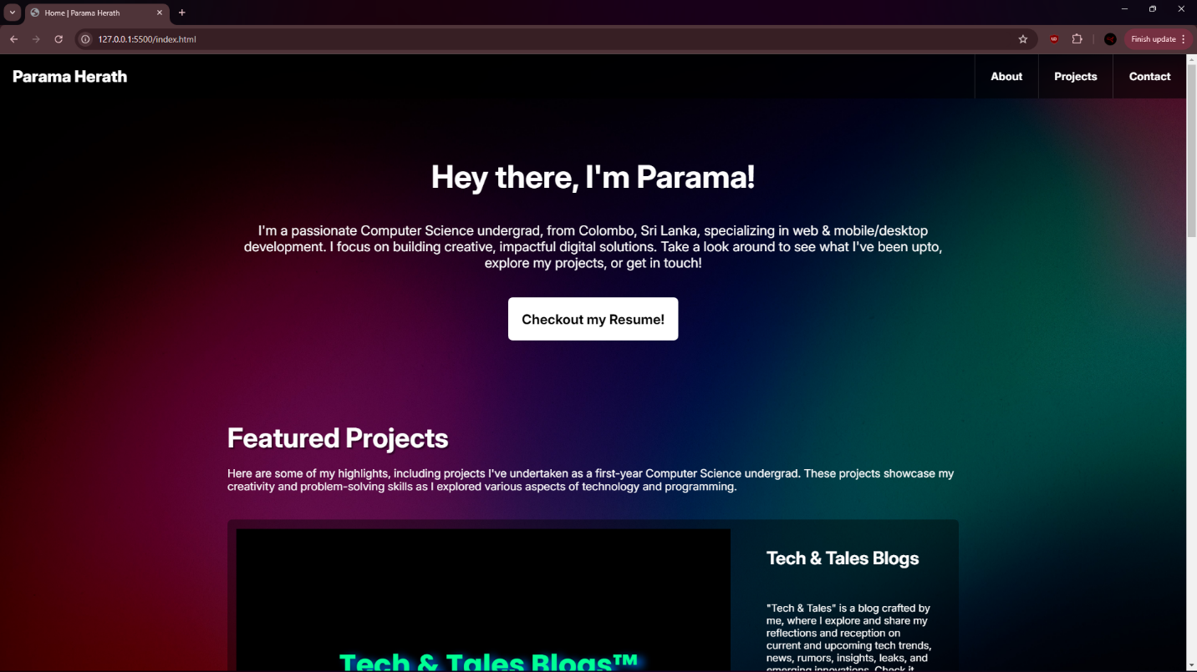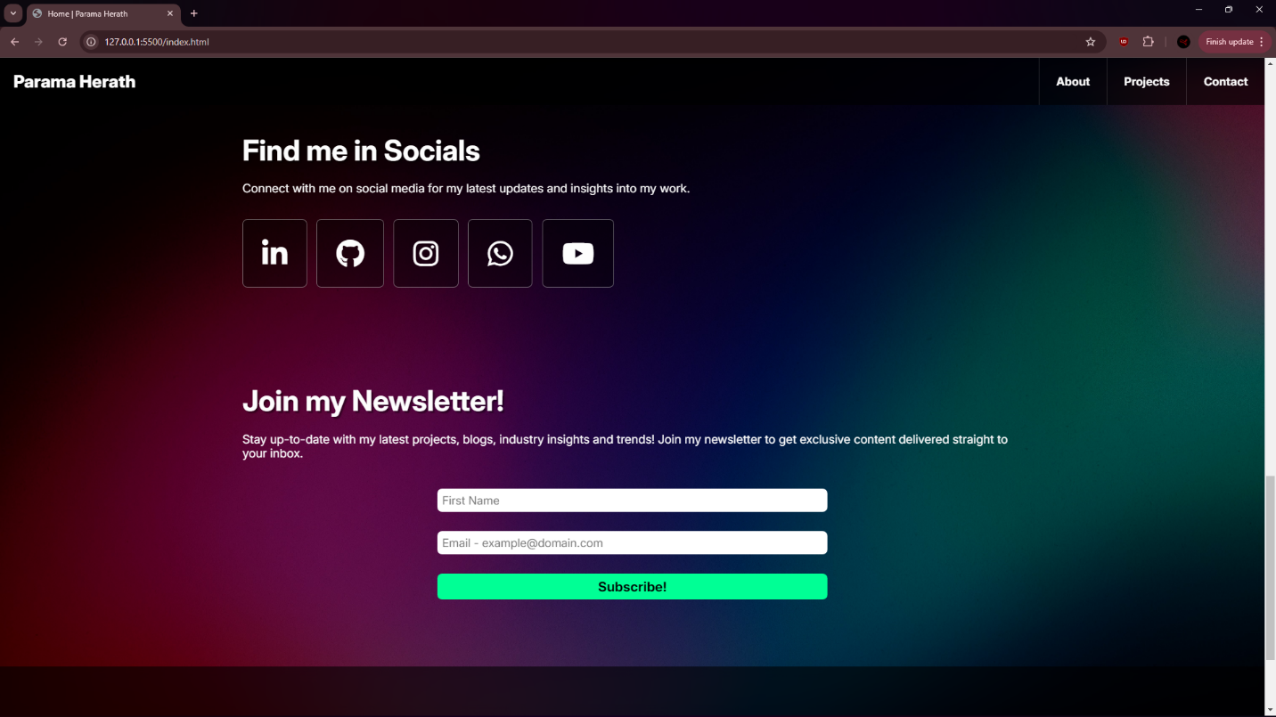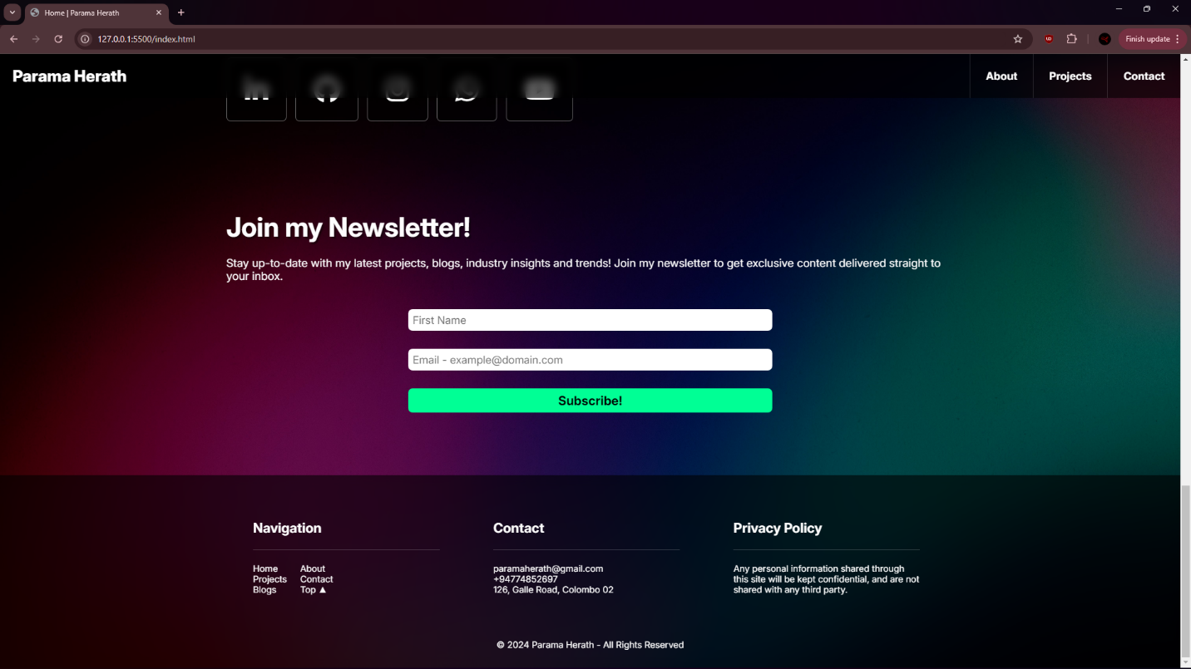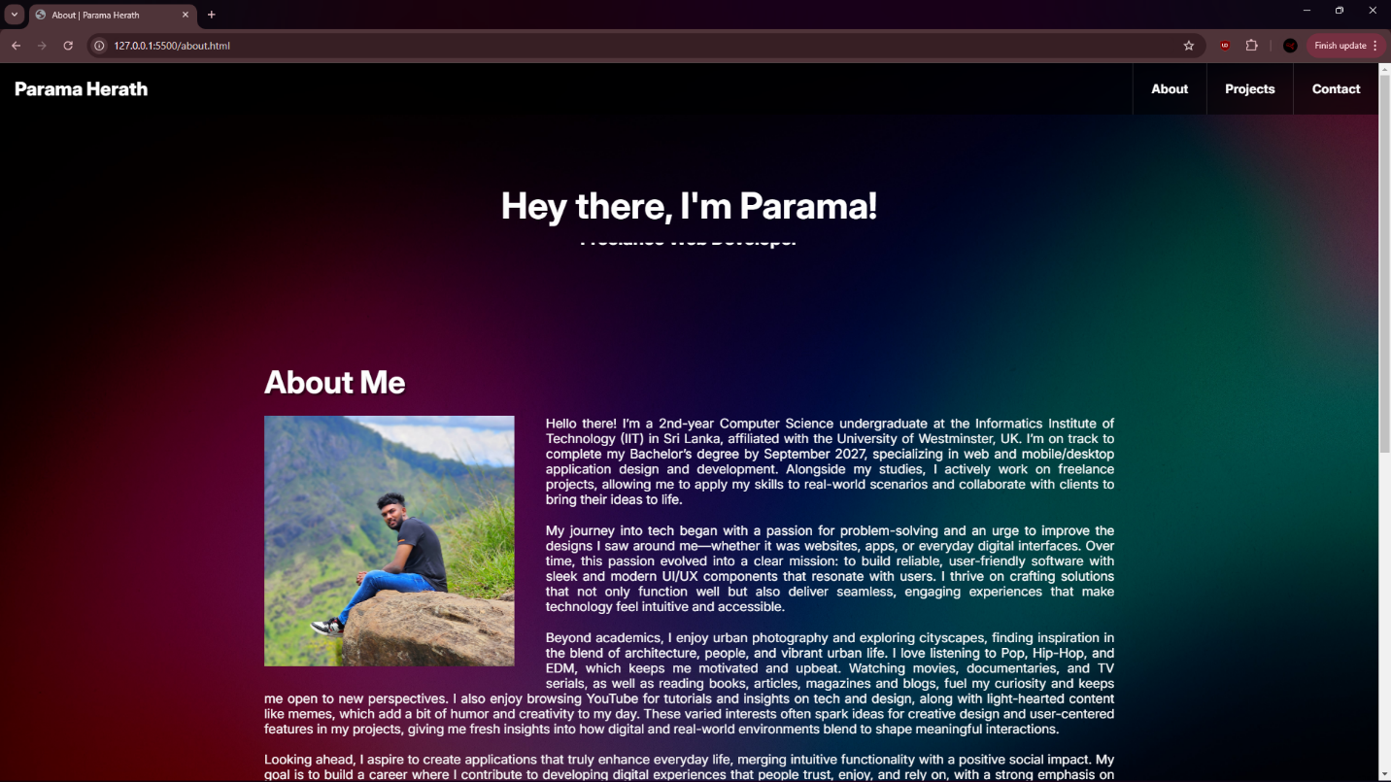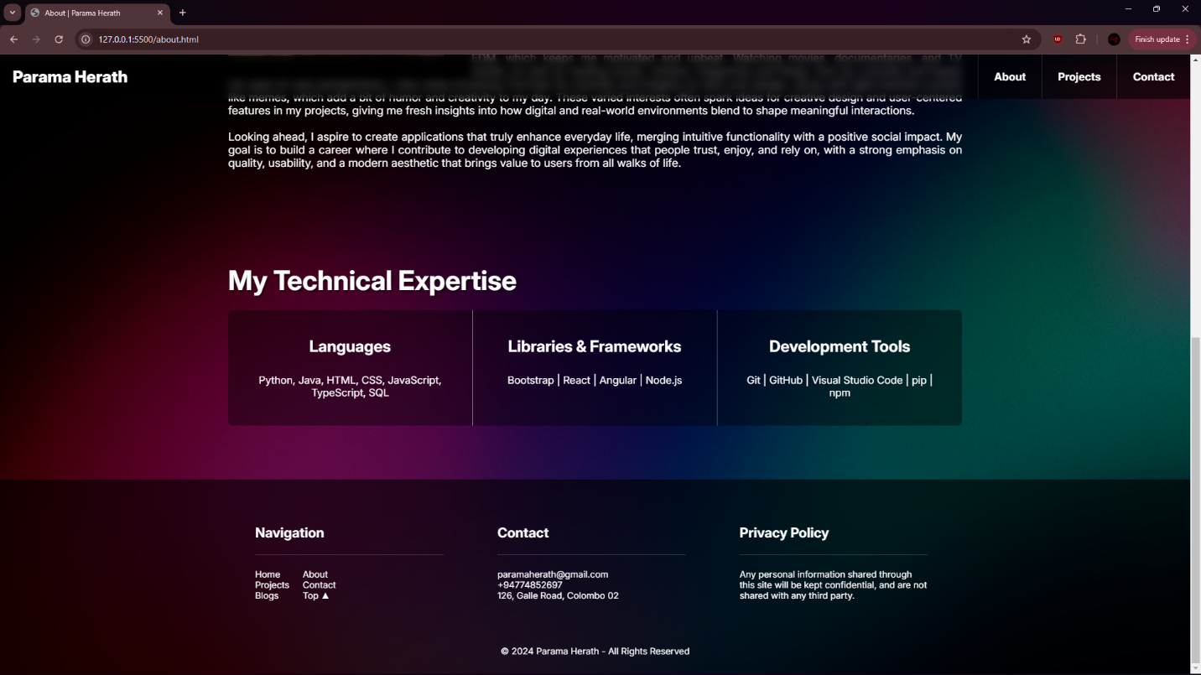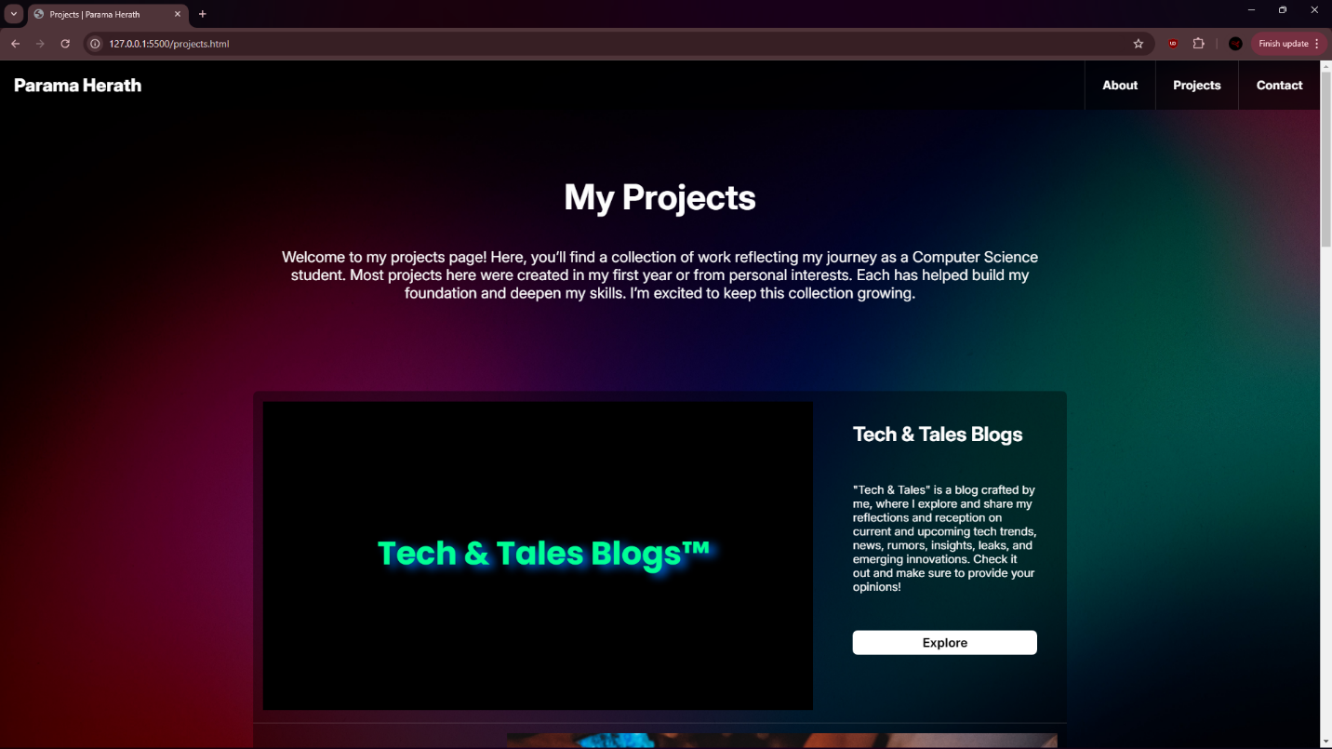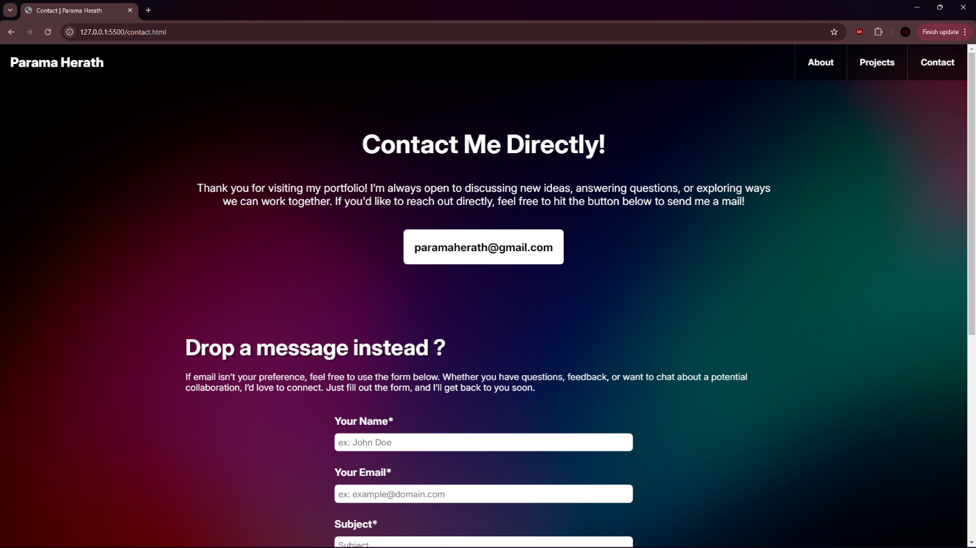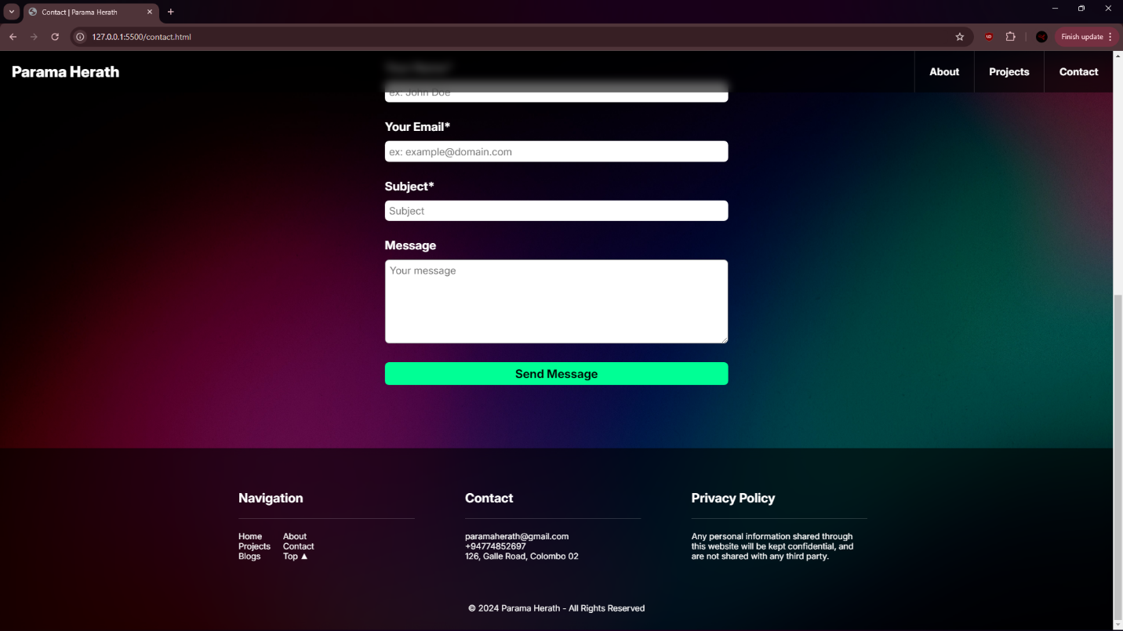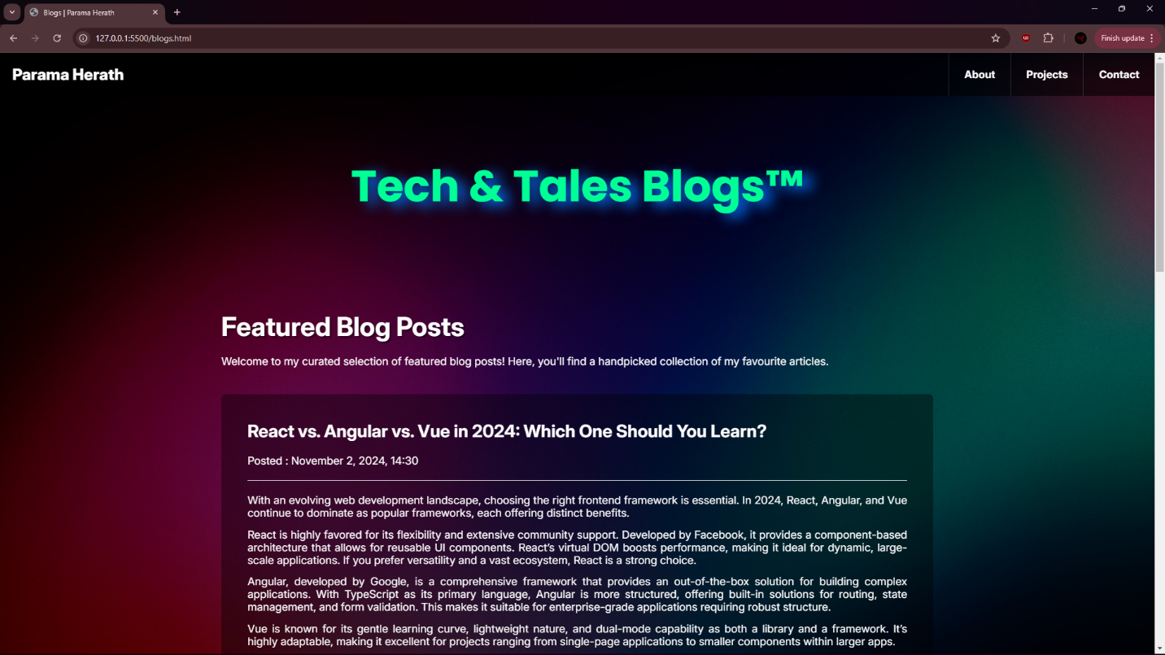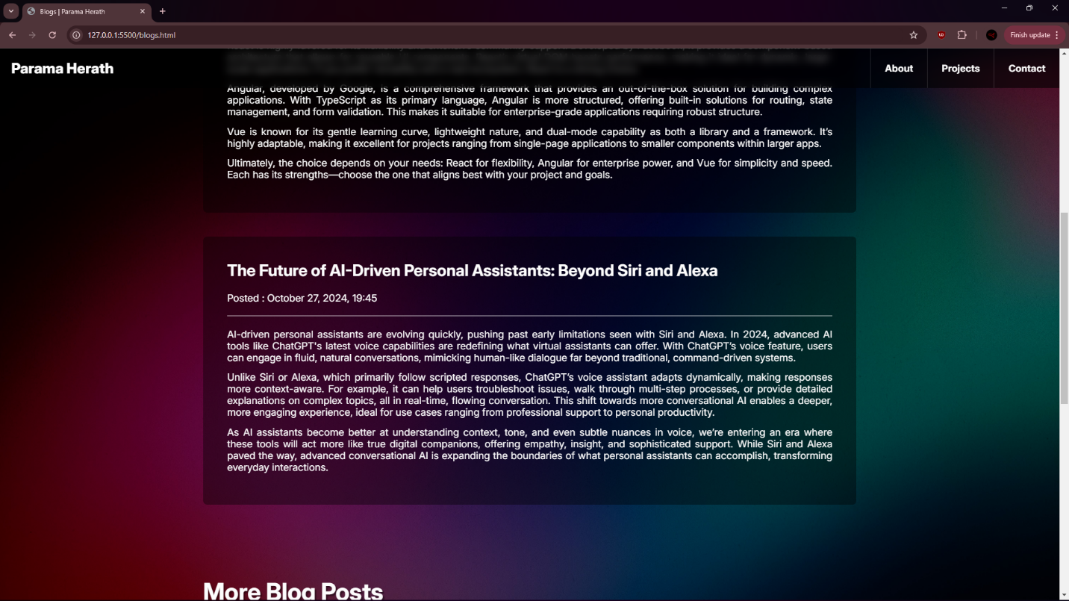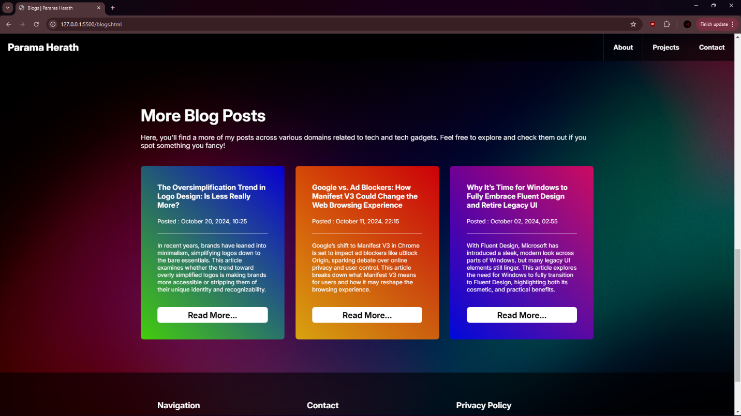

**DEVELOPMENT DIARY FOR THE PORTFOLIO WEBSITE**

**Week 01 – Oct 2-9**

* Decided on the project’s file structure as per the specification, 3 HTML files, for Home, About, Projects and a single CSS file. In addition, a JS file is to be used sitewide.
* Decided the basic navigation as well: Home, About and Projects pages would be accessible via the navigation bar and some featured projects would be shown on the Home page.
* Decided that the newsletter subscription form would be on the bottom of the homepage, before the footer that would be constant sitewide.
* Initial low fidelity diagrams for the desktop and mobile layouts were decided and drawn:

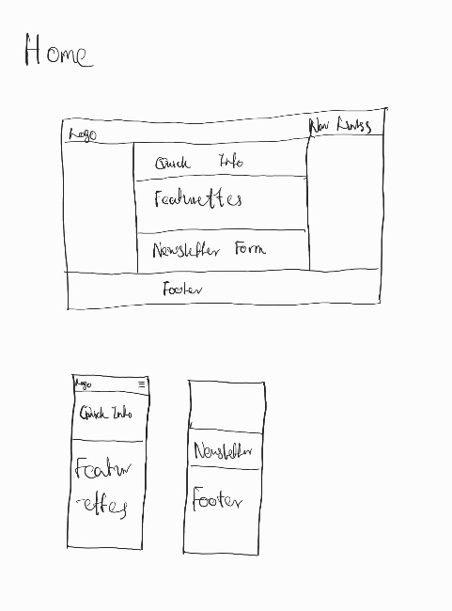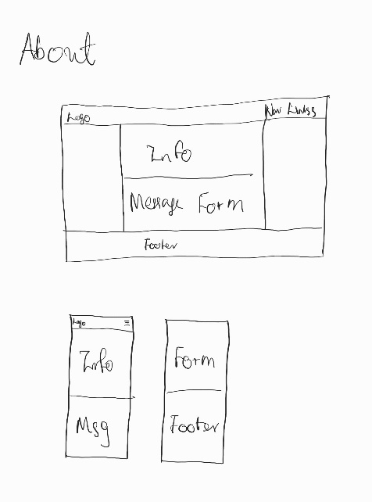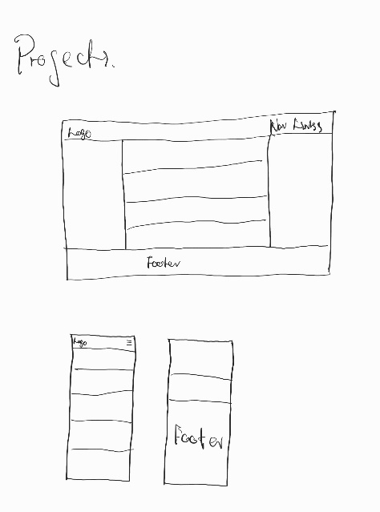

**Week 02 – Oct 9-16**

* Learned that including at least 2 blog posts were mandatory, regardless of choosing to showcase projects over a “more general blogs page”.
* Drew a low fidelity diagram for desktop and mobile layouts for this blogs page:

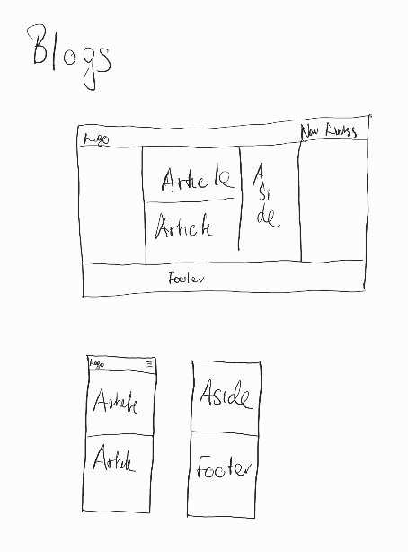

* Started working on the Home page, navigation bar and footer, the latter are to be reused for the other HTML files.
* Added background images, padding and a general first section of the body tag, which would be used to host a greeting and a quick message.
* As I’m developing on a desktop-first basis, made the navigation bar and footer responsive to fit for a mobile device. (ONLY mobile as of now) This is demonstrated by the screenshots below:

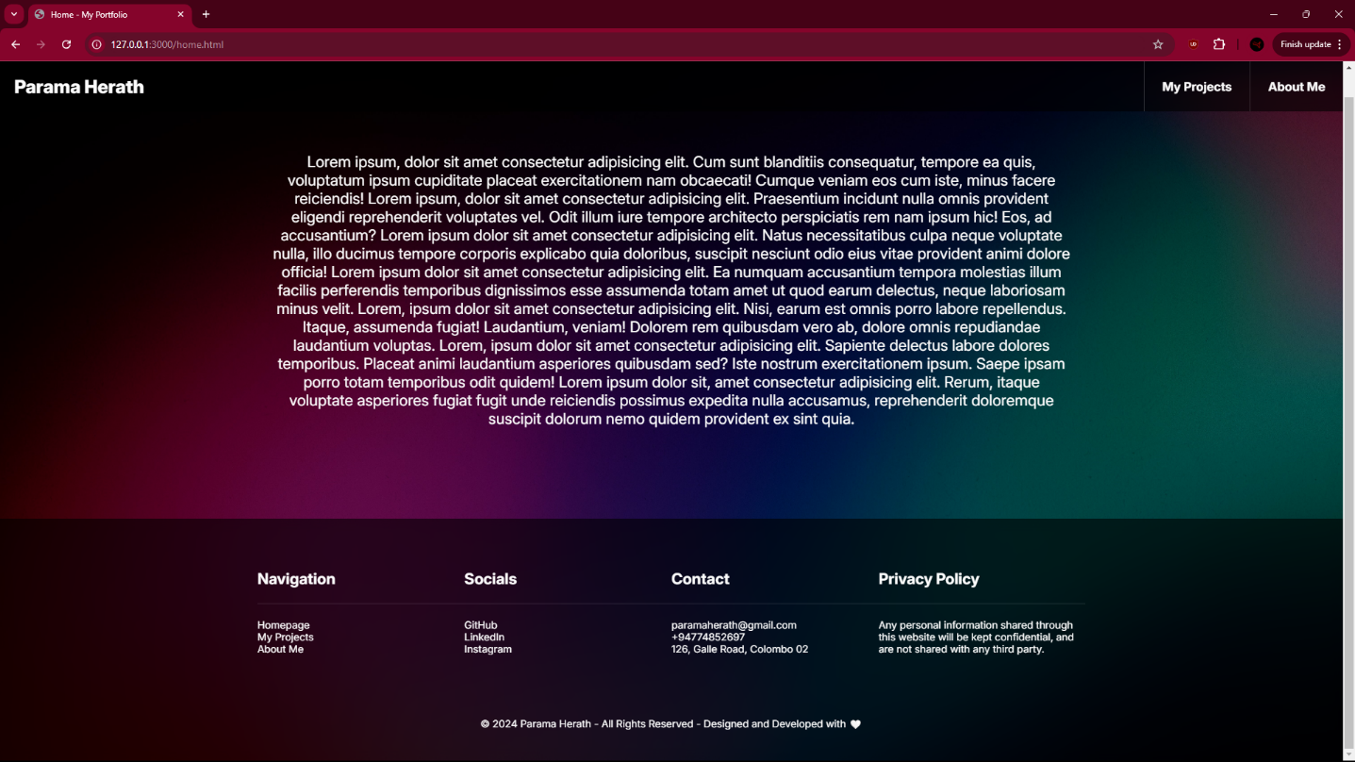

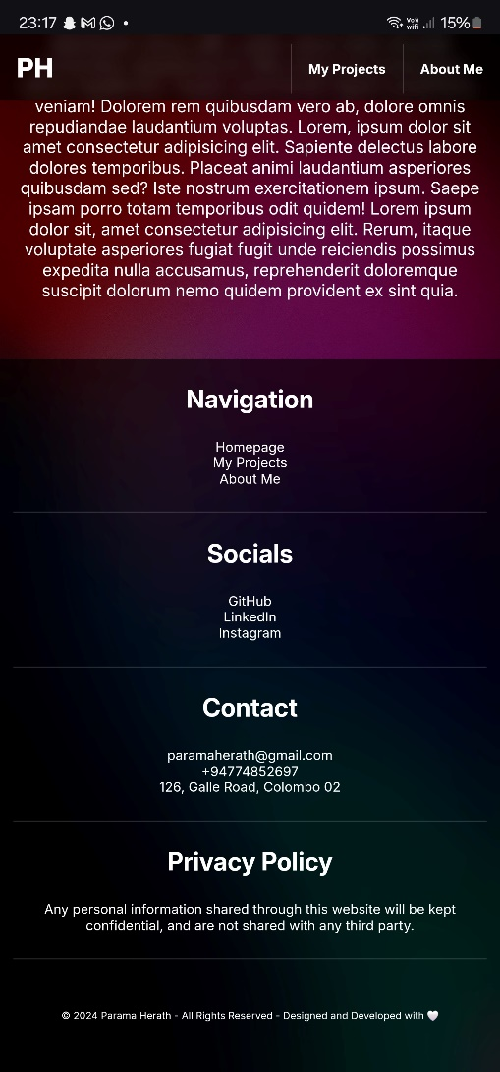

**Week 03 – Oct 16-23**

* Upon realizing that the specification asks for 3 HTML files, a CSS file at MINIMUM, had a change of plans for ease of coding and better management.
* Accordingly, the project structure that 4 HTML files, for Home, About, Projects and Blogs pages and 5 CSS files, for 4 HTML files each and a general sitewide CSS file was decided.
* However, most of the files other than the main HTML and CSS are just placeholders as of now with no at all.
* Finalized the basic navigation structure: Home, About and Projects pages would be accessible via the navigation bar, while the Blogs page would be one of the projects, and be accessible via both Projects, and the featured projects section in the Home page.
* Homepage is almost fully developed at this stage, while other pages are yet to be developed. A screenshot is attached below:

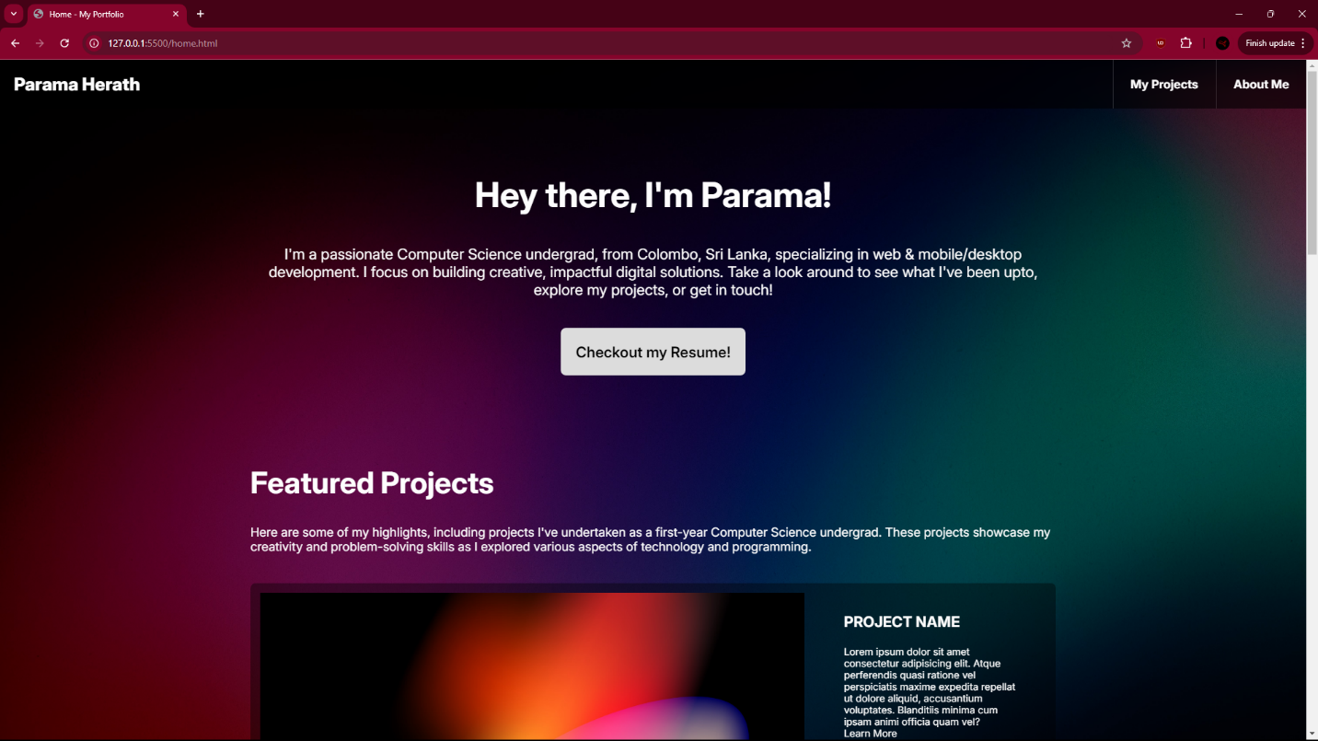

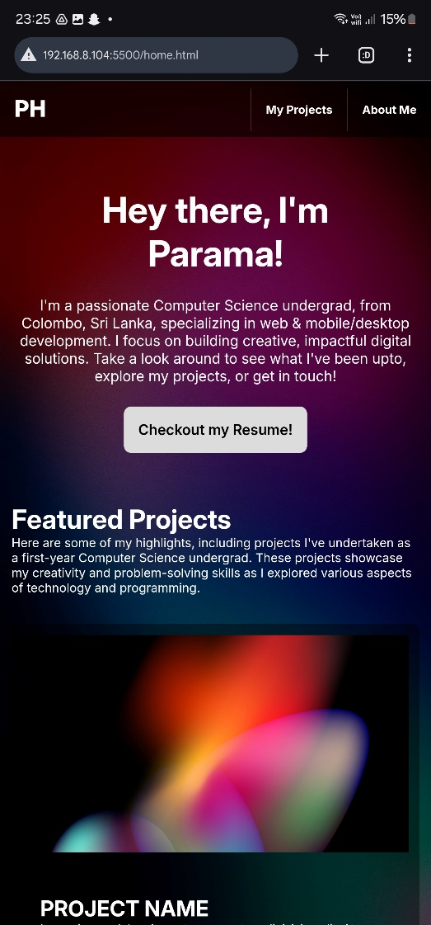

**Week 04 – Oct 23-30**

* Created a repository on GitHub, and the initial commit is the project as it stands of now. The repository is available at: <https://github.com/ParamaHerath/Portfolio-Website-for-ACS-Module>.
* Renamed the home.html file to index.html for GitHub hosting, and the second commit includes these changes. The portfolio is hosted at: <https://paramaherath.github.io/Portfolio-Website-for-ACS-Module/>.
* Built the basic structure of other HTML files and organized the styles into their corresponding CSS files. Created a new branch and committed, which is then to be merged with main branch.
* Developed the basic structure of all other pages, except the Blogs page and added the form to allow a viewer to send me a message in the About page.
* Organized CSS Styles into their corresponding files and optimized them to reduce redundancies.
* Made most of the other pages responsive, and accordingly more commits were made once I had achieved some sort of intended progress, that is named and described in the commit name and description section.

**Week 04 – Oct 30-Nov 5**

* Created a pull request that includes the latest commit, and verified if everything was correct and stable. Later, it was merged with the main branch.
* Upon re-reading the specification, it was evident that I had done a mistake by creating multiple, page specific CSS files, when there should be a SINGLE CSS file for the whole website.
* Adjusted the CSS files and merged all styles into one CSS file named style.css.
* Began work on the Blogs page and developed the other pages further using all required methods of targeting and styles in the specification.
* Made a commit once the above-mentioned tasks were done, which was followed by severed commits and merges as development followed.
* Created a Contact page and moved the Message from there.
* Linked all external resources like blogs, repositories for projects, etc.
* QA Improvements, getting rid of redundant commented out styles, adding more useful class/id names and comments.
* Added alt attributes for images, and ended all development.